***SECTION 1***

***Q1. For 14 July 2021 find the required details-***

* ***Most frequently used payment type***

*ANS : Most frequently used payment type on 14th July is :* **DC**

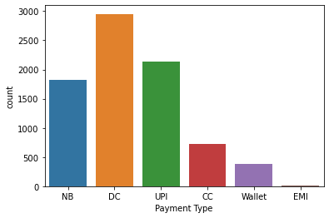

* ***Merchant ID with highest transaction value***

*ANS: Merchant ID with highest transaction value :*

*Merchant ID 11508728*

*Transaction amount 177400.0*

* ***% transactions which were settled by 15th July***

*ANS 56.50548354935194 %*

***Q2. What is the average time taken between transaction & settlement***

***(assume every day settlement happens at 12 noon)***

*ANS : Average time taken between transaction & settlement (assume every*

*day settlement happens at 12 noon) = 32.28959563278962 Hrs*

***Q3. Which payment type has the highest transaction fee %***

*ANS : From the Analysis*

*Transaction Fee % for* ***DC*** *= 0.85 %*

*Transaction Fee % for* ***UPI*** *= 0.0115 %*

*Transaction Fee % for* ***NB***  *= 0.1473 %*

*Transaction Fee % for* ***CC*** *= 1.7169 %*

*Transaction Fee % for* ***Wallet*** *= 1.7989 %*

*Transaction Fee % for* ***EMI*** *= 0.8204 %*

*Therefore we can conclude that highest transaction fee is of :*

*payment type : Wallet*

*Transaction fee % 1.79 %*

***Q4. What percentage of transactions were settled within 1-day?***

*ANS:*

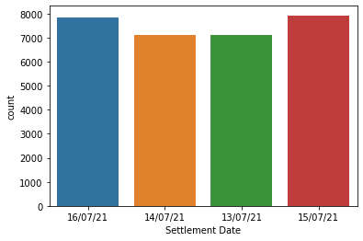

*percentage of transactions were settled within 1-day* ***:*** ***55.36839998665821***

***Q5. Provide hourly trend for transactions for all days together (in a table and a bar***

***graph) And find out the peak/highest hours of transactions?***

***ANS*** *:*

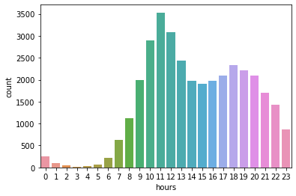

*Therefore, From the graph me can conclude that between 11:00 -*

*12:00 was the peak hours of transactions*

*Now,*

*hours count*

*0 252*

*1 98*

*2 42*

*3 17*

*4 32*

*5 60*

*6 221*

*7 635*

*8 1124*

*9 2000*

*10 2903*

*11 3533*

*12 3083*

*13 2435*

*14 1968*

*15 1903*

*16 1968*

*17 2100*

*18 2341*

*19 2221*

*20 2103*

*21 1707*

*22 1430*

*23 864*

***Hourly Trend for transactions for all days together***

*hours Transaction amount*

*0 1474217.67*

*1 756718.16*

*2 407854.16*

*3 98181.53*

*4 250506.22*

*5 376378.60*

*6 1863439.32*

*7 6463054.16*

*8 8401949.35*

*9 14669722.08*

*10 20116177.99*

*11 21603187.82*

*12 20962391.17*

*13 19231430.20*

*14 16671128.91*

*15 18797800.06*

*16 16406019.95*

*17 14255786.75*

*18 14207410.57*

*19 14447647.40*

*20 16131210.91*

*21 14852447.02*

*22 12157573.80*

*23 7340737.97*

***Q6. Any other interesting insight you can derive from this data***

*Ans : We can also derive which payment type has most no of Failures in the*

*Transaction*

*This is the counts of the* ***Status Column*** *:*

***SUCCESS 34710***

***success 293***

***requested 18***

***queued 15***

***failure 4***

***Graphical Representation :***

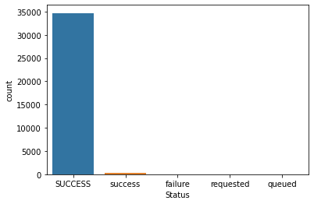

***Now, Data according to every payment types :***

* *For Payment type* ***DC,*** *counts of the* ***Status Column***

***SUCCESS 12252***

***success 36***

***queued 8***

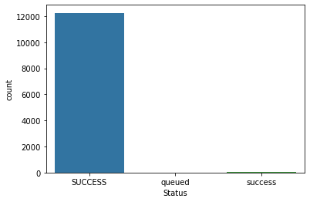

* *For Payment type* ***UPI ,*** *counts of the* ***Status Column***

***SUCCESS 9212***

***success 109***

***failure 4***

***queued 2***

***requested 1***

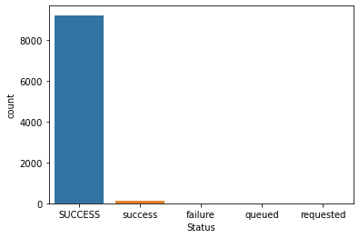

* *For Payment type* ***NB ,*** *counts of the* ***Status Column***

***SUCCESS 8074***

***success 80***

***requested 17***

***queued 3***

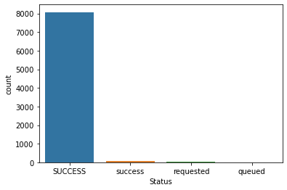

* *For Payment type* ***CC ,*** *counts of the* ***Status Column***

***SUCCESS 8074***

***success 80***

***requested 17***

***queued 3***



* *For Payment type* ***Wallet ,*** *counts of the* ***Status Column***

***SUCCESS 8074***

***success 80***

***requested 17***

***queued 3***



* *For Payment type* ***EMI ,*** *counts of the* ***Status Column***

***SUCCESS 8074***

***success 80***

***requested 17***

***queued 3***



***Conclusion :***

***Therefore from the above data we can conclude that only the Payment type***

***UPI has Failure in transaction i.e Failure = 4 .***